臺北市立松山高級工農職業學校101學年度外國交換學生
歡迎會暨相關事項說明會
2012 SongShan High School of Agriculture and Industry
Rotary Exchange Student Welcome Ceremony

- 分班及配課需求
- Placement
- 感謝各位皆已回覆期望學習的科別，學校會儘量依您所願進行安排。但擔心各位對日前您所看到的簡介資訊不夠瞭解。因此希望再一次確認各位相就讀的科別。
Thanks to everyone for completing their learning program selections, our school will try to accommodate your request as much as possible. However the program literatures might not have provided sufficient description to each of those programs; therefore, we would like to reconfirm your selection one last time.

- 本校共有52個不同性質的社團，有音樂、運動、學術、服務…等性質的社團，歡迎您的加入參與。
We have 52 different kinds of school clubs, including music, sport, academic, public service and so on. Welcome to join one of the clubs you like.

- 在校期間的實習課程，主要會安排與園藝科、食品加工、機械科有關的課程供各位參與學習。
Based on the program chosen, the school will arrange lab hours in gardening, food processing, and machinery, depending on availability.

- 學校每日上課時間共7節課，每節課50分鐘。
You are required to attend 7 sessions a day, 50 minutes each session.

- 相關注意事項：
- Related notes:
- 正式上學日期為：101年9月5日。並請於上午7：30分前至教務處報到，於朝會時，校長介紹給全校，結束後由導師引導入班。
School starts on Sep 5st. Please go to Academic Affairs Office on 7:30 a.m. and sign your name.

- 請於正式上學日當日繳交半身照片電子檔（如無電子檔，可直接提供照片掃描）、中文姓名及護照號碼，以便製作學生證悠遊卡。
On the first day of school, please bring one ID photo (electronic or paper photo) and give us Chinese name and passport number to apply student cards.

- 交換學生在校期間相關規定
- Regulations relating to the exchange students at SAIHS
- 早上需於7：40以前到校，不得於下午4：20以前離校。
Please arrive at school no later than 7:40am, and leave school no earlier than 4:20pm each day.

- 早上到校後及下午離校前，需至教務處簽名。
Please Sign in/out at the Academic Affairs Office every day you arrive/ leave the school.

- 中午休息時間為12：35~13：00，需跟隨班級午休，不得隨意在校園內遊蕩。
12:35~13:00 is school break time. Please stay in the classroom.

- 如有相關活動，須提前到校，務必遵從學校或導師要求時間到校。
On special occasions, follow school or teacher's instructions to arrive at the school earlier.

- 不論平日或假日，進出校門一律穿著學校制服或運動服，不得穿著便服，亦不應以任何理由規避穿著校服。
Regardless of school days or weekends, wear school uniforms to school at all times. School uniform includes gym uniforms and designated school bags

- 上學請勿配戴任何飾品，包含耳環、戒指、指甲油、項鍊…等。
Do not wear accessories of any kind to school including earrings, rings, finger-nail or toe-nail polish.

- 每日將聯絡本主動給老師及寄宿家庭簽名，每週三下午將聯絡本送至教務處蓋章。
School Contact Book must be signed by your teacher and host family parent every day. Turn in your School Contact Book to Academic Affairs Office every Wednesday afternoon

- 請每週撰寫週記，記述有關生活上、學習上及心理上的心得，並送交老師批閱。
Keep your weekly journal and hand it to your teacher every week. The content can include your learning, feelings or anything you want to share.

- 每日按照課表準時至教室上課，上課中不得有睡覺、聽MP3、使用手機或筆記型電腦等不禮貌的行為。
Attend your classes according to the class schedule. Do not use MP3, mobile phones or notebooks during class. Do not sleep in class.

- 務必準時上、下課，不可以遲到或早退，也不可以在未經得任課教師、導師或學校同意之下，自行離開上課教室或學校。
Do not be late or leave school early. Without the consent of teachers or the school, do not leave your own classroom or school.

- 生活上及學習上如有不瞭解或清楚的時候，應主動詢問同學，不應以不清楚老師或學校規定，規避學習及生活常規。請注意，校園內禁止吸菸，校外不得著校服吸菸
If you have any question relating to learning or daily life, do not hesitate to ask your classmates. Being unfamiliar with the school regulations is not an excuse to violate the school rules. Attention, you can not smoke anywhere in the campus, and nor outside the campus with uniforms.

- 第一學期請盡量使用中文與老師及同學溝通，第二學期開始務必在校內使用中文語言。
You do your best to use Mandarin to communicate with your teachers and classmates during the first semester. You will be requested to use only Mandarin in school during the 2nd semester.

- 校外中文學習課程結束後或扶輪社例會結束後，應立即返校，不得在校外遊蕩。
Return to school immediately after you finish your monthly rotary club meetings.

- 凡因事請假(含扶輪社活動或病假)，請務必通知導師或教務處。無故曠課達42節，依校規轉知扶輪社遣送回國。
If you need personal leave which includes rotary activities or sick leave, please inform your teacher or Academic Affairs Office early. If absenteeism over 42 hours, we will inform Rotary to repatriate you.

- 積極參與班級與學校活動。
Please participate in classroom and school activities enthusiastically.

- 其他
- Others
- 請準備好簡單的自我介紹，9月5日將安排上台與全校同學認識。他日如有需要再安排各位做深入的介紹。
Prepare a simple self-introduction to allow school students to get to know you on Sep 5st.

- 學校期中期末考期間將視情形，另安排文化交流活動給各位參與。
During school midterms and finals, we will arrange other activities for you.

- 中文學習及生活上如有何任問題，本校已安排王柏文老師協助輔導各位。
If you need further assistance, please contact Gisele Wang at the Academic Affairs Office, ext. 232.
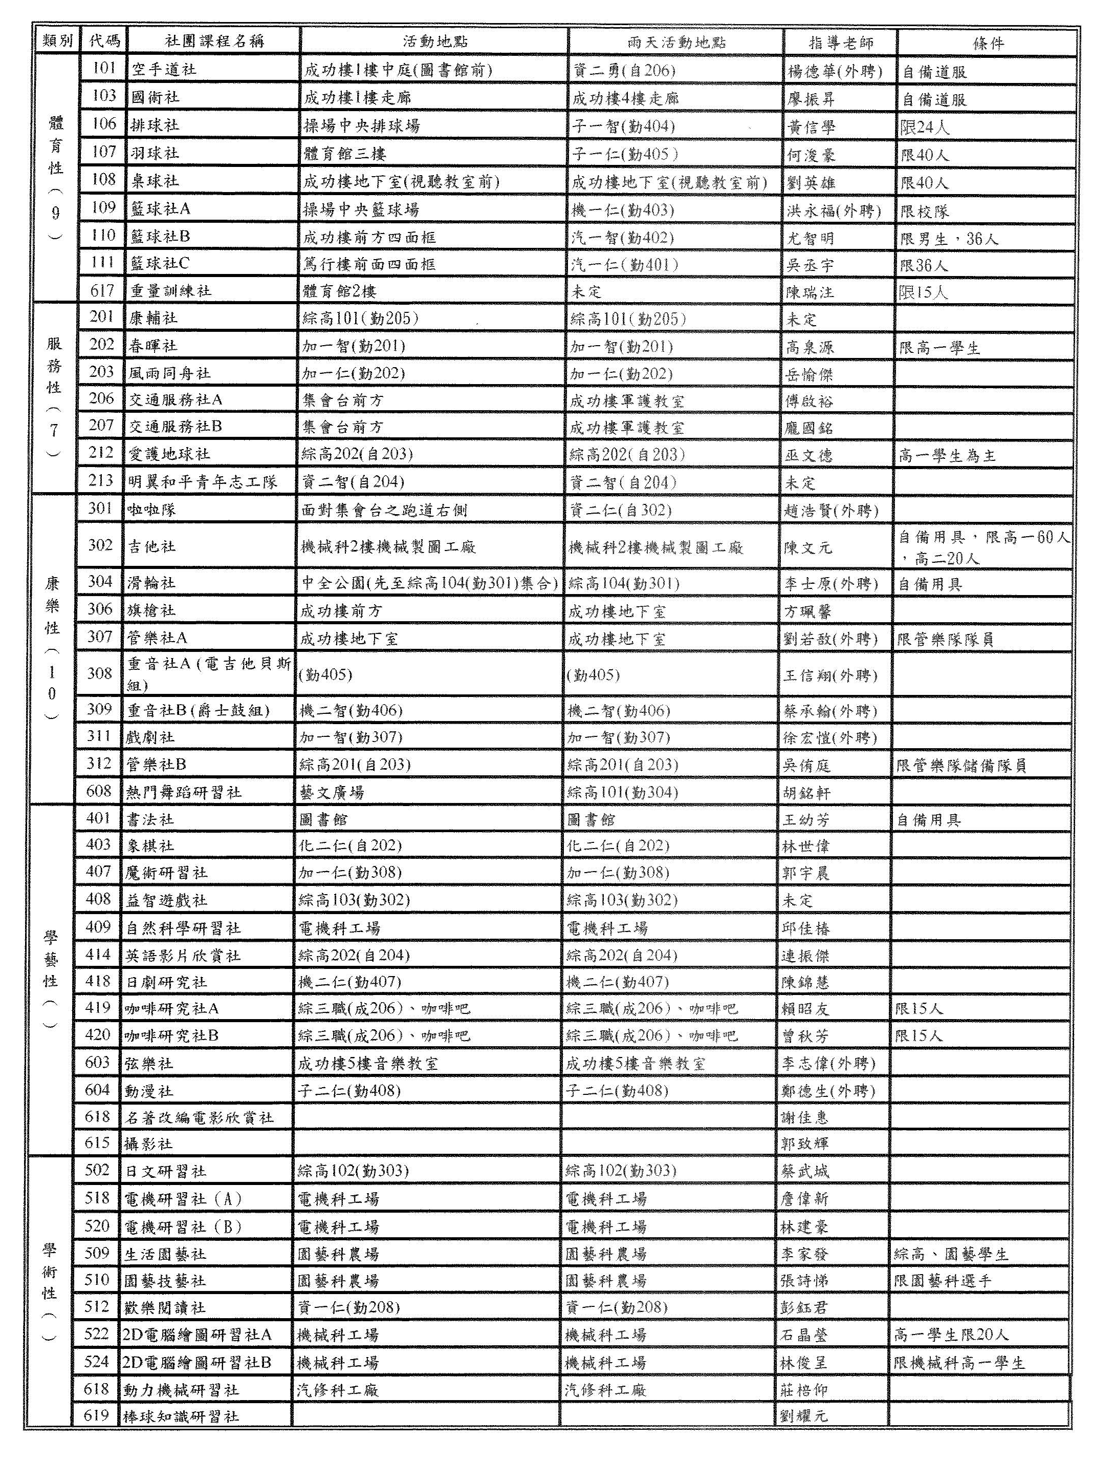
【此為暫定版，開學正式選社團時將可能有微調】

同意書
Agreement

我願意遵守交換學生在校期間相關規定。

I agree to abide by regulations relating to the exchange students at SAIHS.


Signature:_____________
Signature(C):_____________
Date:___________

